Case Study myRetail RESTful service

Technologies/Tools Used for Case study

1. Spring Boot 1.4.2.RELEASE
2. Spring Security (Basic authentication)
3. Eh Cache
4. Swagger 2.6.1 using Springfox API
5. Cassandra 2.1.8
6. Spring Data
7. slf4j logger
8. jUnit
9. Mockito
10. Maven 3
11. JDK 1.8
12. STS 3.9.0

How to run application:

The application can be started by running the below maven command

mvn clean install spring-boot:run

API Information Document

API Information is available under swagger UI below

<http://localhost:8080/swagger-ui.html#/>

username : myretail

password : myretail

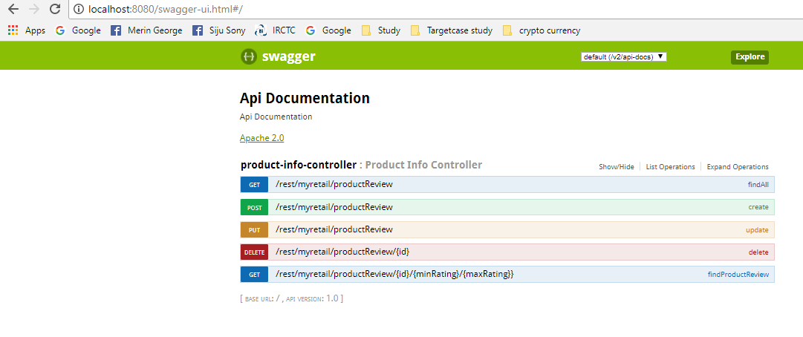

Get Request Info : will get number or reviews and all reviews for the given range

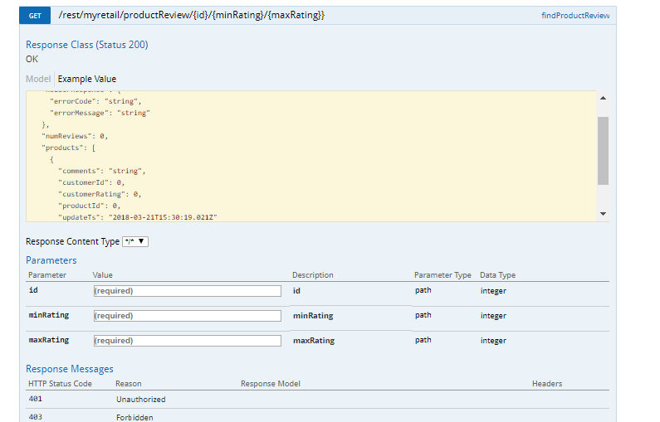

POST Request Info

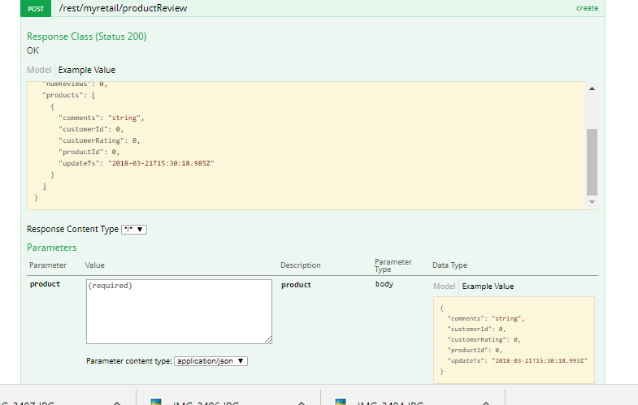

Testing of Application

Testing was done unit junit with mokito

ProductInfoServiceTest.java

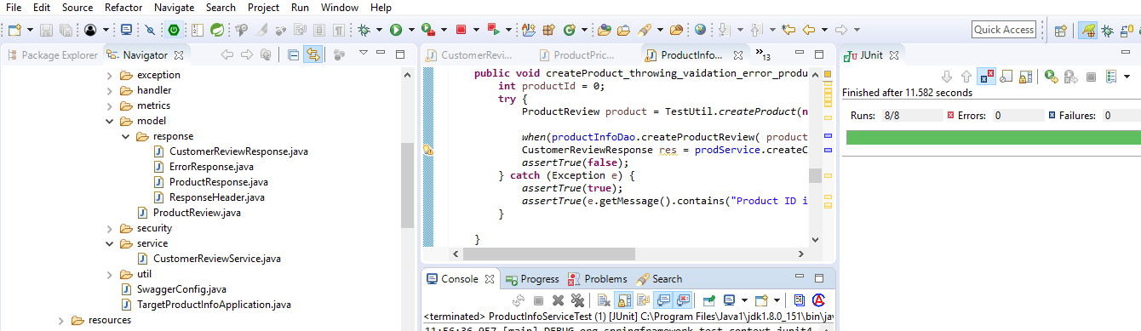

Cassandra table Format

Table is designed in such a way that the latest record for a particular product is always available as first record

CREATE column family customer_review(

product_id bigint,

customer_id bigint,

update_ts TIMESTAMP,

customer_rating bigint,

comments TEXT,

PRIMARY KEY ((product_id),customer_id , update_ts)

) WITH CLUSTERING ORDER BY (update_ts DESC);

create index customer_review_rating on customer_review (customer_rating);

Indexing was done to enable query based on rating